Lab Report 1: Component Tolerances, Ohm’s Law and Kirchhoff’s Laws

Verification of Circuit Laws
The experimental results agree with the expected behavior of the relationship between Ohm’s Law and KVL and KCL. The total voltage of the circuit was in proportion to the equivalent resistance of the circuit found through KCL and KVL analysis. The measured voltages were almost or exactly found to the theoretical calculations.

Effect of Component Tolerances
Resistor and component tolerances influenced our measurements for my $V_{cd}$ and $V_{ab}$, two resistors that are equivalent in voltages by being in parallel. Real world applications where component tolerances are critical are cutting edge, ultra-efficient semiconductor devices like high end graphics and central processors in smartphones.

Potentiometer-Based Circuit Design
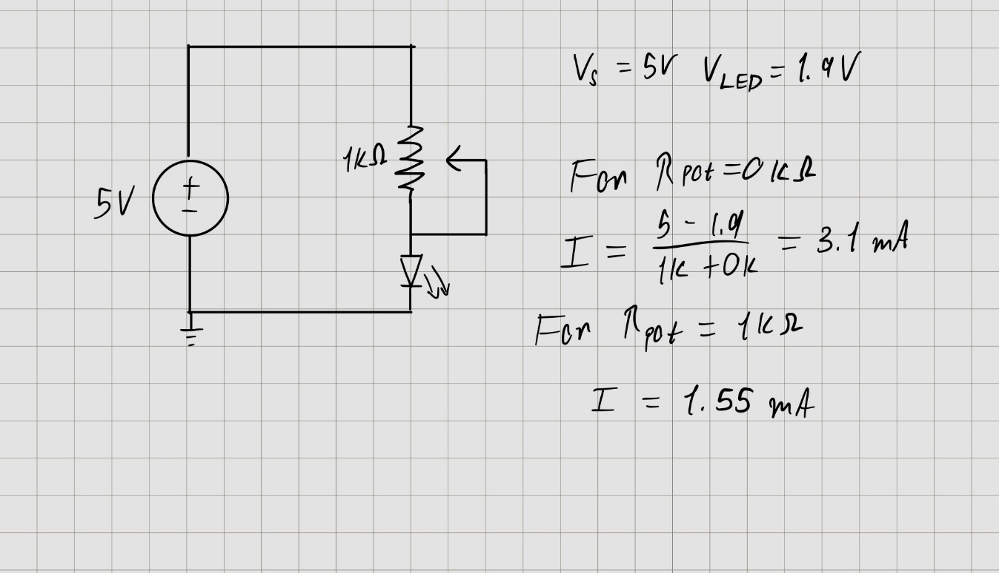

A Dimmer is used to control the current or brightness of an LED.
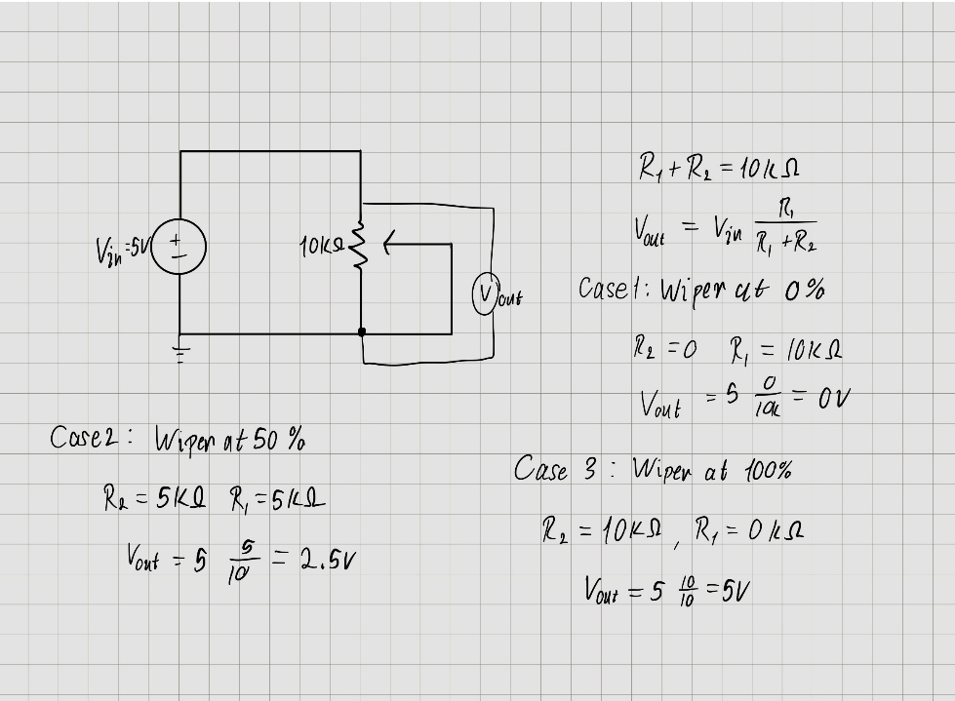
A voltage divider is used to produce a variable output voltage

